Newsletter
Issue 22

1 March 2024

Dear Parents and Carers

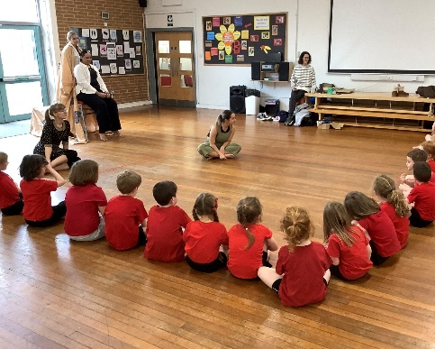
Dance Workshop
Year 1 were treated to a Dance Workshop this week by students from Winchester University. They enjoyed the story telling and joining in with the activities.

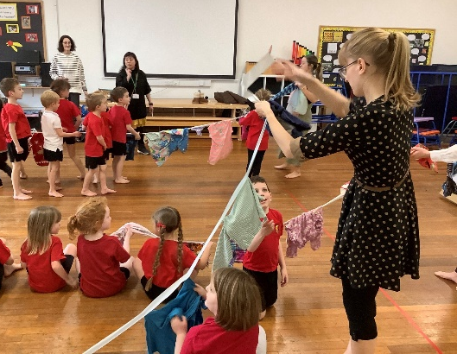

Edible Garden
The children have resumed their edible garden sessions this term on Thursdays. Please can we ask that they bring suitable clothing for these sessions. Please ensure that they have coats in school and wellington boots.

Parents Evenings
We will be holding Parents Evenings next week on Wednesday 6 and Thursday 7 March. These will be taking place between 3.50pm and 6.50pm on the Wednesday and 3.50pm and 5.30pm on the Thursday. Ms Langridge’s parents evenings (Year 5) are Tuesday 5 and Wednesday 6 March. There is still time to sign up on Monday and Tuesday. If you are not able to get into school to sign up please contact the Admin Team who will be happy to make an appointment for you.

Mothers Day Shop
The PTA are once again running their Mothers Shop from 4 – 8 March from the PTA Shed before and after school. They will be offering the children a selection of wrapped gifts. Cash and Cards accepted.

World Book Day
To celebrate World Book Day on Thursday 7 March, children can come to school dressed as a character from a book in place of their uniform.

We will send home a Book Token which entitles each child to select a title from a specially commissioned set of World Book Day books that can be picked up from supermarkets or book shops.

In addition to this, children will bring home a picture of a library and hidden within it are 26 well-known book titles. To be in with the chance of winning a Book Token, all you have to do is name as many of the books as you can and ask your child to write a compelling brief book review of their favourite title from the selection that you find.

If you'd like your child to participate, please send the picture with the hidden book titles, and your chosen book review on the back of it, into school for the following Thursday (15 March) and the winners will be announced in assembly on Friday 16 March. Enjoy searching for the hidden titles!

Lunchtime/Playtime Leaders

The children who were chosen this week were:
Danny W - Bumblebees
Tinson Y - Foxes
William B - Herons

Football Club
We are happy to announce that we are able to offer this club to girls and boys in Years 3 and 4 after the Easter holidays. They will be running on Wednesday’s after school and will run from Wednesday 17 April through to Wednesday 22 May. The cost will be £48 for the half term. For more information and to sign up please go to: bookwhen.com/mattwellsfootballcoaching.

Learning Behaviours
We have held this week’s Learning Behaviours assembly. This is where a teacher chooses a child/children that has demonstrated the chosen learning behaviour of the week. The teacher shares with everyone what the child has done and then we all celebrate their achievement. This term we are looking at resilience. The children who were chosen this week were:

Year One Isla Mc
Year Two Imogen F
Year Three William B, Samuel P
Year Four Archie H
Year Five Riley T
Year Six Joshua S

School Lunches
Thank you to everyone for settling their lunch accounts, however the lunch debts are still high - please could you ensure that your account is kept up to date. For your information the money owed per class is as follows:-
Hares £ 141.33
Foxes £ 78.75
Herons £ 158.15
Kingfishers £ 203.00
Nursery £ 172.40

Please could we ask that your child does not order a school lunch if the debt is above £10.00 and to provide them in a packed lunch. Please can you arrange to clear your Lunch accounts as soon as possible.

If you would like an up to date statement of your child’s account please contact the Admin Team. If you have not yet registered to pay online via Scopay and would like a copy of your login details please email us and we will be happy to help. We would appreciate it if all accounts, including any outstanding Breakfast Club and After School Club accounts, could be settled as soon as possible. Please ensure that your After School Club Account is up to date as we employ extra staff for this club. If you would like an up to date statement please contact the school office.

Thank you for your continued support.

Yours faithfully

Mrs Bordoli
Interim Headteacher

Dates for your diary (new dates in red)

Parents Evenings (Year 5 - 5 and 6 March) 6 & 7 March 2024
World Book Day 7 March 2024
Year 1 trip to Science Centre 13 March 2024
Ferny Crofts Residential Trip Meeting (Year 5) 3.40 20 March 2024
School Choir 3pm 27 March 2024
Herons Egyptian Dress up day (Year 5 only) 28 March 2024
School breaks up for Easter 28 March 2024
School returns 15 April 2024
Year 5 trip to Ferny Crofts 24 - 26 April 2024
Inset Day 28 June 2024
Inset Day 1 July 2024
School breaks up for summer 23 July 2024

